PIZZA SALES SQL QUERIES

KPI”S REQUIREMENT:

1.TOTAL REVENUE:

SELECT SUM(total_price) AS total_revenue from PIZZA_SALES;

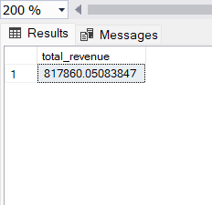

2.AVERAGE ORDER PER ID:

SELECT SUM(total_price) / COUNT(DISTINCT order_id) AS AVG_ORDER_ID from PIZZA_SALES;

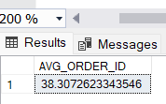

3.TOTAL PIZZA SOLD:

SELECT SUM(quantity) AS total_pizza_sold from PIZZA_SALES;

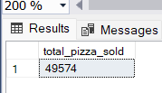

4.TOTAL ORDERS:

SELECT COUNT(DISTINCT order_id) AS total_orders from PIZZA_SALES;

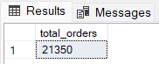

5.AVERAGE PIZZA PER ORDER:

SELECT CAST(SUM(quantity) AS DECIMAL(10,2))/

CAST(COUNT(DISTINCT order_id) AS DECIMAL(10,2))AS avg_pizza_per_ord from PIZZA_SALES;

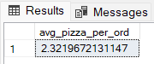

CHARTS REQUIREMENT:

1.DAILY TREND FOR TOTAL ORDER:

SELECT DATENAME(DW, order_date) as order_day,COUNT(DISTINCT order_id) as total_order

from PIZZA_SALES

GROUP BY DATENAME(DW, order_date);

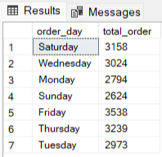

2.DAILY TREND FOR TOTAL ORDERS:

SELECT DATENAME(MONTH, order_date) as order_month,COUNT(DISTINCT order_id) as total_orders

from PIZZA_SALES

GROUP BY DATENAME(MONTH, order_date)

ORDER BY total_orders DESC;

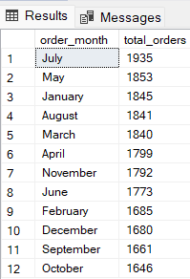

3.PERCENTAGE OF SALES BY PIZZA CATEGORY:

**SELECT pizza_category ,SUM(total_price)*100 / (SELECT SUM(total_price)**

**from PIZZA_SALES) AS PCT from PIZZA_SALES**

**GROUP BY pizza_category;**

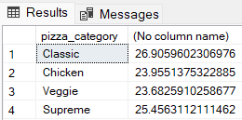

4.PERCENTAGE OF SALES BY PIZZA SIZE:

SELECT pizza_size ,CAST(SUM(total_price)*100 / (SELECT SUM(total_price)

from PIZZA_SALES) AS DECIMAL(10,2)) AS PCT from PIZZA_SALES

GROUP BY pizza_size;

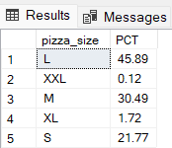

5.TOTAL PIZZA SOLD BY PIZZA CATEGORY:

SELECT pizza_category ,COUNT(DISTINCT order_id) AS pizza_sold,

SUM(total_price) AS revenue from PIZZA_SALES

GROUP BY pizza_category;

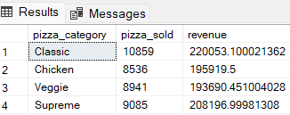

6.TOP 5 BEST SELLER BY REVENUE,TOTAL QUANTITY AND TOTAL ORDER:

SELECT TOP 5 pizza_name,SUM(total_price) as total_revenue,

count(quantity) as pizza_quantity,count(DISTINCT order_id) as total_order

from PIZZA_SALES

group by pizza_name

order by total_revenue DESC;

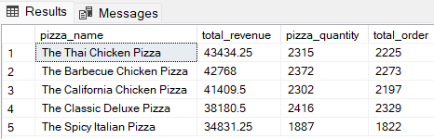

7.TOP 5 WORST SELLER BY REVENUE, TOTAL QUANTITY AND TOTAL ORDER:

SELECT TOP 5 pizza_name,SUM(total_price) as total_revenue,

count(quantity) as pizza_quantity,count(DISTINCT order_id) as total_order

from PIZZA_SALES

group by pizza_name

order by total_revenue;

